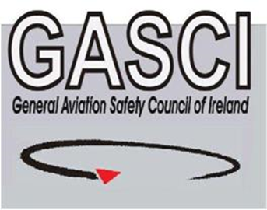
GASCI Generic Outbrief
Aim: Is the flight fully briefed and the aim understood?
Licence, Type/Class ratings & Medical, all Valid? Am I in current flying practice?
Weather suitable & Briefed?
Aircraft - Any relevant snag history/Limitations?
Fuel – TYPE Mogas/Avgas or Jet A1? - Adequate for planned & Diversions with reserve?
Performance calculations OK for all destinations?
Maps/charts/approach plates carried & in date? Aircraft/GPS database up to date?
Correct up-to date Checklist carried?
NOTAMS & Local restrictions checked?
Flight plan/GAR required?
PPR done if required?
Route planned? Fuel? En route Diversions? Safety Altitude? Controlled Airspace? Life jackets required? Skydemon/GPS/ tablet use briefed? Power source adequate? Route programmed? Airfield charts downloaded?
End of Day VFR time? (end of Civil Twilight - SERA) Night current if no IR held?
Passenger: Safety briefed? Headeset? Sick Bag available? Passport required?
Signed out in Tech Log and booked out iaw local procedures?
TEM – Pick one & Discuss/Consider Mitigation for your flight:
Runway Incursion/Excursion; Taxi Restricted/Congested Manoeuvring area; Fuel Type - Jet A1 Vs Avgas fuelling Error; Take-off abort; EFATO; Mid-Air collision; In-Flight Icing; Bad weather avoidance; CFIT avoidance; Loss of Control; Birdstrike;

